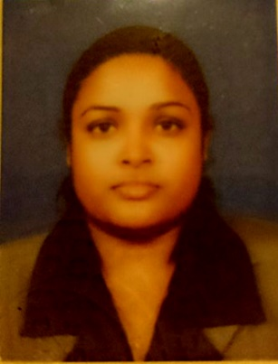**Chathuri Nisansala Gunawardhane**

No 114/2,

Kandawala, Katana

Negombo.

Con: (0094) 771115286

Email: [chathurom.nish@gmail.com](mailto:chathurom.nish@gmail.com)

**Career Objectives**

To secure a challenging position where I can effectively contribute my skills, and innovative ideas to gain knowledge in the work environment.

**Education Qualification**

* General Certificate of Education Ordinary Level 2007
* General Certificate of Education advanced Level 2010

**Strengths**

* Hard working and friendly
* Disciplined
* Honest
* Team working

**Current Academic Background**

* Following an IT Engineering degree at **Sri Lanka Institute of Information Technology** (**SLIIT**) (2012 - 2016)

**Other Qualifications**

* Followed a “Certificate Course In Computer Literacy” at **Technical Engineering College (Sri Lanka)** – 2003
* Followed a “Certificate Course In Computer Studies” at **Technical Engineering College (Sri Lanka)** – 2004
* Participated in “Provincial Education Software Competition for Schools 2006” conducted by **Secondary Education Moderation Project of Ministry of Education & Microsoft Sri Lanka (Pvt) Limited.** - 2006
* Participated in “Provincial Education Software Competition for Schools 2007” conducted by **Secondary Education Moderation Project of Ministry of Education & Microsoft Sri Lanka (Pvt) Limited.** - 2007
* Followed a course in “Certificate in Information Technology” at **Esoft Computer Studies Private Limited** – 2008
* Followed a “Cambridge ESOL Entry Level Certificate in ESOL International (Entry 2)* (KET)” at **University of Cambridge ESOL Examinations** – 2008
* Followed a “Cambridge ESOL Entry Level Certificate in ESOL International (Entry 3)* (PET)” at **University of Cambridge ESOL Examinations** – 2011
* Followed a “English Language Full Time (Intermediate) Course” at **Regent Language School** – 2012
* Followed a “Diploma in Airline Fares / E ticketing, GDS, Reservation, Tours, Marketing, Cargo & Airport Operation Course (Travel & Tourism) **IATA** “at **International Airline Ticketing Academy by Deepal Perera.** – 2015

**Achievements**

* Inter-House Athletic Meet under 13 Net-Ball 2nd place 2003 – **Harischandra National College.**
* Inter-House Athletic Meet under 15 Shot-Put 2nd place 2005 – **Harischandra National College.**
* Inter-House Athletic Meet under 15 Javelin Throw 3rd place 2005 – **Harischandra National College.**
* Inter-House Athletic Meet under 15 Net-Ball 2nd place 2005 – **Harischandra National College.**
* School Sports – Negombo Division under 15 Volley-Ball 3rd place 2005 – **Harischandra National College.**
* Annual Inter-House Sports Meet under 17 Foot-Ball 1st place 2007 – **Harischandra National College.**
* Annual Inter-House Sports Meet under 17 Net-Ball 2nd place 2007 – **Harischandra National College.**

**Personal Profile**

Name : Chathuri Nisansala Gunawardhane

Date of birth : 1st February 1991

Age : 24 years

Sex : Female

Nationality : Sri Lankan

Address : No 114/2, Kandawala, Katana

Contact no : (0094) 771115286

Email : chathurom.nish@gmail.com

Marital status : Single

Language known : Sinhala, English

**Non Related Refries**

A.G.U.K. Abeynayaka L.N.Harshani

Electrical Engineering Manager Directress of Studies

ACL Cables PLC The Regent

Cont: (0094)773675425 High Educational Center of Sri Lanka

Cont: (0094)773411617

**Declaration**

I hereby declare that the information furnished above is true to the best of my knowledge.

--------------------------------- --------------------------------

C.N.Gunawardhane date